AMMAN ARAB UNIVERSITY
جامعة عمان العربـيــــــة
College of Computer Sciences and Informatics
كلية العلوم الحاسوبية والمعلوماتية

Lost and found board

Fayza Ahmad mohammad | 202120780
Yara Emad Ghannam | 202110467
Sereen Ramzi Abdul-Aziz | 202220596

Supervisor

Dr. Alaa
Title | Page
Problem statement | 3
Business case | 3
Scope | 3
Goals | 4
Project Plan and Schedule | 5
Gantt Chart | 5
SDLC Model | 6
Functional Requirements | 7
Use Case Diagram | 8
Class Diagram | 9
System Architecture Diagram | 10
ER Diagram | 11
User interface(UI) | 12
Design patterns | 15
code documentation
Unit Test
Table of Contents

Table | Title | page
Table 2.1 | Project Plan and Schedule for GymFit | 5
Table 6.1 | Unit Test for GymFIT
Figure | Title | page
Figure 2.2: | Gantt chart for GymFit | 5
Figure 5.1: | UseCase diagram for GymFit | 8
Figure 5.2: | Class diagram for GymFit | 9
Figure 5.3: | System Architecture Diagram | 10
Figure 5.4: | ER Diagram | 11
Figure 5.5: | Sign Up UI For GumFit | 12
Figure 5.6: | Sign In UI For GumFit | 12
Figure 5.7: | Workout Suggestion UI for GymFit | 13
Figure 5.8: | Gym membership subscription UI For GymFit | 14
Figure 5.9: | Profile management UI For GymFit | 14
Figure 5.10: | Class Diagram for Singleton Pattern | 15
Figure 5.11: | Class Diagram for Factory Pattern | 16
Figure 5.12: | Class Diagram for Strategy Pattern | 17
List of Figures
List of Tables
- Introduction
  - Problem Statement

At universities, students frequently lose personal belongings such as
student ID cards, keys, wallets, phones, or study materials , While there
are individual attempts to communicate through WhatsApp or Facebook
groups, these efforts are disorganized, making it difficult to locate lost items
quickly, There is no central system withinthe university that makes it easy
for students to report lost items or find them safely and easily.

  - Business Case
Creating a dedicated app or website for lost and found items within the university will provide a unified and secure platform that will help:
- Reduce the time and effort required to find lost items.
- Enhance the university's image by adopting smart solutions to serve students.
- The app could also be expanded in the future to include other universities or educational institutions..

  - Scope
The scope includes:
- Developing a university-specific application (or website).
- Allowing students to create accounts using their university email addresses.
- The ability to upload posts containing photos and descriptions of lost or found items.
- A search function within posts.
- Communication between users via private messages or comments.
- A simple user interface similar to social media applications.

  - Goals:

4.1 Creating a secure and user-friendly digital platform for finding

lost items within the university:
The project aims to develop a reliable application that allows students to report and find their belongings easily through a simple and clear user interface.
    - Reduce the rate of lost and unretrieved items by at least 50%:
Through the organized system and quick access to information, students will be able to retrieve their belongings much faster compared to traditional methods
    - Promoting Cooperation and Responsibility Among Students:
This project aims to foster a spirit of cooperation within the university community by encouraging students to help each other find lost items

Facilitating the Reporting of Lost and Found Items in Minutes:
The application allows users to quickly and easily upload a post containing a photo and description of the lost or found item without requiring significant effort or complicated procedures

- Planning & Management
5
  - Project Plan and Schedule
Table 2.1 shows the project plan and schedule for the Lost and found boar
system, outlining the main phases from requirements gathering to final
documentation ,The table includes five key phases, each containing
specific activities to achieve the project objectives.It also presents the
start and end dates for each phase, with a duration of one week per stage.
Through this table, the workflow and time allocation between tasks can be
clearly tracked.This structured planning helps ensure that the project is
completed efficiently and within the scheduled timeframe

Table 2.1: Project Plan and Schedule for Lost and found board

Phase | Activities | Start Date | End Date | Duration
Phase 1: Requirements Gathering | - Problem Statement  - Business Case  - Scope  - Goals  - Functional Requirements | 4/11/2025 | 12/11/2025 | 1 week
Phase 2: System Design | - UseCase Diagram  - Iser Interface  - ER Diagram  - System  - Architecture (MVC)  - Gantt Chart  - Class Diagram | 24/7/2025 | 3/8/2025 | 1 week
Phase 3: Implementation | - Frontend development  - Database creation  - backend integration | 1/8/2025 | 16/8/2025 | 1 week
Phase 4: Testing | - Unit Test  - Bug Fixes | 14/8/2025 | 23/8/2025 | 1 week
Phase 5: Finalization | Documentation | 21/8/2025 | 30/8/2025 | 1 week

  - Gantt chart
In Figure 2.2 the Gantt chart represents the time line and the tasks ,
in the Gantt chart we show 6 main tasks with their subtasks we
start with the introduction which includes the problem statement,
research strategy, and scope then in the second task is the Literature
Review and it will have related work as well as it will have a lot of
information and research, after that we have the methodology that
will have the feasibility study and the methodology process, after it
we have the model design which contains the context diagram, data
flow diagram, case diagram, ER diagram and the relational model,
afterwards we will have the experiment and the results which will have
the testing and its methodologies as well as the discussion on the project
and the evaluation of the project, lastly we will have conclusion and future
work which will have the conclusion of the research and project and the
future work will mention how and where can we improve and which areas
can we improve on in the project.

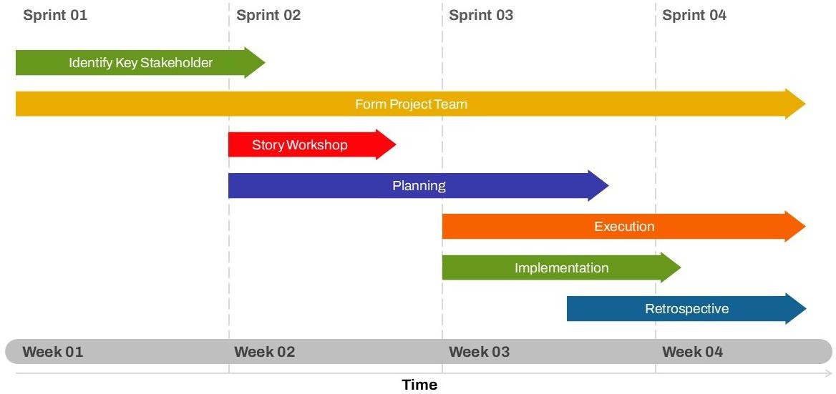
Figure 2.2: Gantt chart for Lost and found board

- Development Methodology (Agile Scrum)

  - SDLC Model (Agile Scrum)
The development of the Lost & Found Board (LFB) system will
follow the Agile methodology, which focuses on flexibility, iteration,
and continuous feedback. The process is divided into short development
cycles called sprints, allowing the team to deliver working features step
by step and adapt to any changes efficiently.

3.1.1 Requirements
User needs are collected through interviews and surveys, then converted
into user stories and prioritized in the product backlog

Sprint Planning

The team selects the highest-priority user stories from the

backlog and defines the goals and tasks for the upcoming sprint.

3.1.3 Design & Implementation
Features are designed and developed in small, manageable parts. Each
sprint focuses on delivering functional components of the system

3.1.4 Testing

Testing is carried out continuously during development. Each

feature is verified to ensure it meets the acceptance criteria and

works as intended

3.1.5 Review & Feedback
User needs are collected through interviews and surveys, then converted
into user stories and prioritized in the product backlog

3.1.6 Deployment & Improvement

The team selects the highest-priority user stories from the

backlog and defines the goals and tasks for the upcoming sprint.

4. System Requirements
4.1 Functional Requirements(FR)

- User Management

FR 1.1 : The system shall allow users to register with a unique email and password, and add ID nationality.

FR 1.2 : The system shall allow users to log in and out securely.

FR 1.3 : The system shall allow users to update their profile information (e.g., name, contact number).

FR 1.4 : The system shall support password reset functionality.

FR 1.5 : Users can upload proof of ownership (photo, receipt, serial number) when claiming a lost item, and the system automatically verifies it against the post description.

- Post Management

FR 2.1 : The system shall allow users to create a Lost Item post with details including:
Item name, Description, Date/time lost, Location lost, Image upload.

FR 2.2 : The system shall allow users to create a Found Item to post with similar details.

FR 2.3 : The system shall allow users to edit or delete their own posts.

FR 2.4 : The system shall store all posts in a searchable database.

FR 2.5 : When a user wants to claim an item, the system compares their information with the post description.

FR 2.6 : If the information matches, the post automatically updates to "Claimed" without Admin intervention.

FR 2.7 : If the information is unclear or suspicious, the system notifies the admin only.

- Search and Filter

FR 3.1 : The system shall allow users to search for posts based on:
- Item name
- Category (Lost / Found)
- Location
- Date range

FR 3.2 : The system shall allow users to filter results by post type, date, or location.

FR 3.3 : The system automatically flags any suspicious claims, and the Admin sees only these cases.

- Notifications and Contact

FR 4.1 : The system shall allow users to express interest in a post (e.g., “I found this item” or “This belongs to me”).

FR 4.2 : The system shall send a notification/email to the post creator when someone shows interest.

FR 4.3 : The system shall provide a way for users to contact each other (email sharing).

FR 4.4 : After verifying a valid claim, the system displays temporary contact information (phone or email) to the users to coordinate item handover, which can be hidden after completion.

- Admin Functions

FR 5.1 : The system shall allow admins to view all users and their activities.

FR 5.2 : The system shall allow admins to manage all lost and found posts.

FR 5.3 : The Admin can review only the suspicious claims.

Non-Functional(NFR)

- Performance Requirements:

NFR 1.1 : The main dashboard page should fully load within 2 seconds on a standard broadband connection (10 Mbps) after a successful login.

NFR 1.2 : The system shall support at least 100 concurrent users without a noticeable performance degradation (< 10% increase in response time)..

NFR 1.3 : Added a requirement specifying that automatic verification processes (proof of ownership, claim matching) should execute quickly, e.g., within 3 seconds per
claim.

- Usability Requirements
NFR 2.1 : The website should be easy to use for both students and staff.
NFR 2.2 : The design should work well on desktops and tablets.
NFR 2.3 : Clear instructions should be available for main features like posting and searching.
NFR 2.4 : Added a requirement to ensure users clearly understand how to upload proof of ownership and claim items safely

- Reliability Requirements

NFR 3.1 : The system should be available and work at least 99.5% of
the time.

NFR 3.2 : If there's an error while submitting a post, user data should
not be lost.

NFR3.3: Added a requirement to ensure the automatic verification process is reliable and accurate, preventing wrongful claims.

- Availability Requirements

NFR 4.1 : The system should be accessible 24/7, except during
scheduled maintenance.
NFR 4.2 : Maintenance should not happen during busy campus hours.

- Security Requirements

NFR 5.1 : Only verified university users can access the WBA.

NFR 5.2 : Passwords should be stored securely (encrypted).

NFR 5.3 : Users shall be automatically logged out after 15 minutes of inactivity for security purposes..

NFR 5.4 : Admins should be able to manage content and users.

NFR 5.5 : Temporary contact information must be visible only to verified users and automatically hidden after the process is completed.

NFR 5.6 : Uploaded files (images, proofs) must be scanned for viruses or security threats.

- Maintainability Requirements
NFR 6.1. The system should be easy to update and fix when needed
NFR 6.2. Errors should be logged for future debugging.

- Portability Requirements
NFR 7.1 : The system should work on all common web browsers (Chrome, Firefox, Safari, Edge).
NFR 7.2 : It should run on different operating systems, like Windows and Linux.

- Compatibility Requirements

NFR 8.1 : The system should accept standard image formats (JPG, PNG).
NFR 8.2 : It should work with university email or login systems.

- Scalability Requirements

NFR 9.1 : The system should handle more users and posts in the future without issues.
NFR 9.2 : The automatic verification and claim processing must scale efficiently as the number of users increases.

- Compliance Requirements

NFR 10.1 : User data should be kept private and used responsibly.
NFR 10.2 : Users should agree to terms of use before posting or using the web-based application.
NFR 10.3 : The system must comply with university policies regarding data storage and privacy.

4. System Design
4.1 Use Case Diagram
Lost and found board offers a seamless, user-centered fitness experience with personalized plans, easy account management, and smooth interactions that keep users focused on their goals.In Figure4.1 shows UseCase diagram of Lost and found board

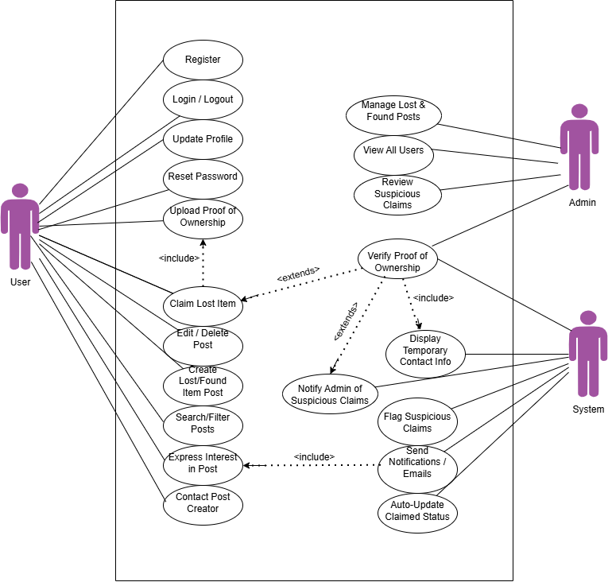

Figure 4.1: UseCase diagram of Lost and found board

  - Class Diagram

GymFit’s backend connects user accounts, subscriptions, and personalized workouts through a secure, modular system for a seamless fitness experience.

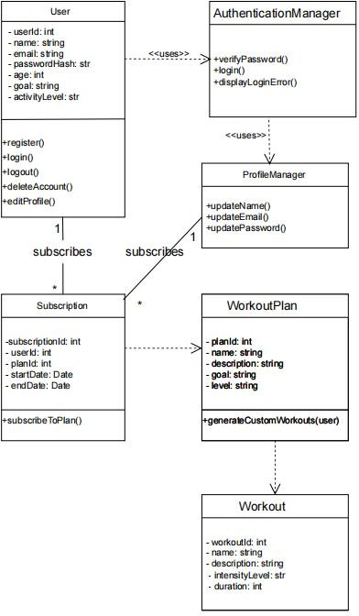

Figure 5.2: Class diagram For GymFit

  - System Architecture Diagram

4.4 ER Diagram
The diagram Figure 4.4 shows illustrates an Entity-Relationship (ER) model representing a database structure. It defines key entities such as User, Post, Item, Comment, Claim, Location, Category, and Notification, along with their attributes and relationships. The model shows how users create posts, write comments, submit claims, and receive notifications, while items belong to categories and are associated with locations. Overall, it visually maps how data elements interact within the system

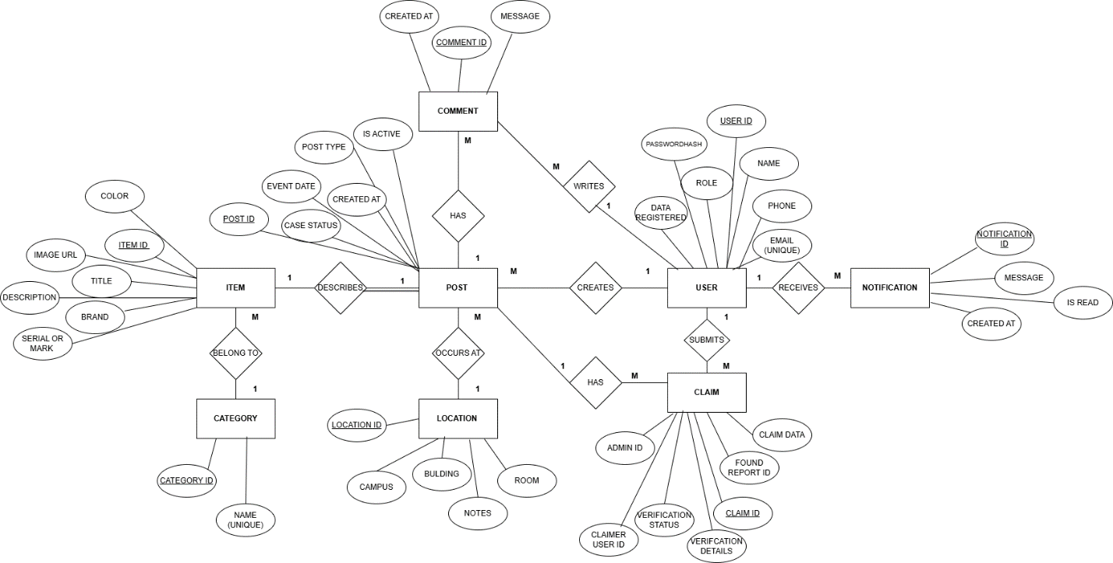

Figure 4.4: ER Diagram for Lost and found board

  - User Interface(UI)
The user interfaces for all pages of the LFB web application have been designed and implemented

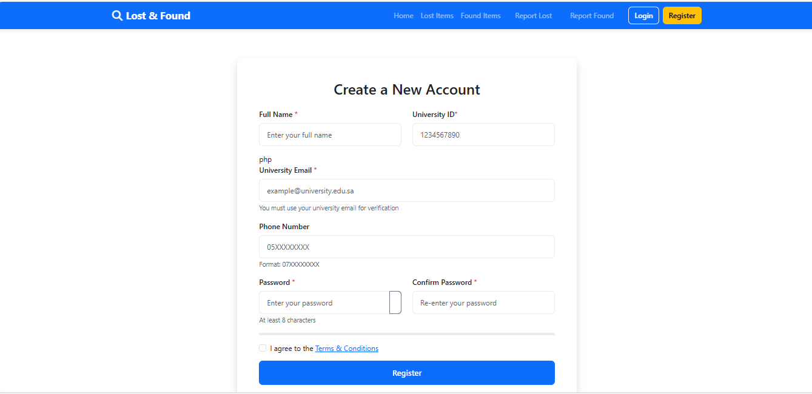Figure 5.5: Sign Up UI For LFB

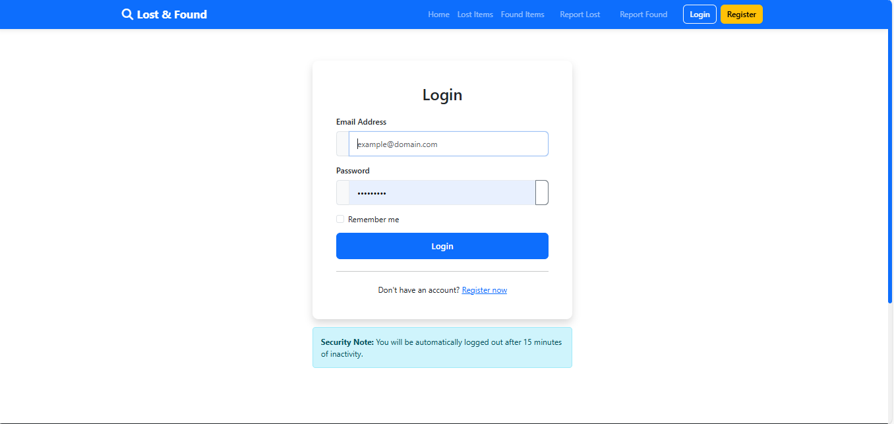Figure 5.6: Sign In UI For LFB

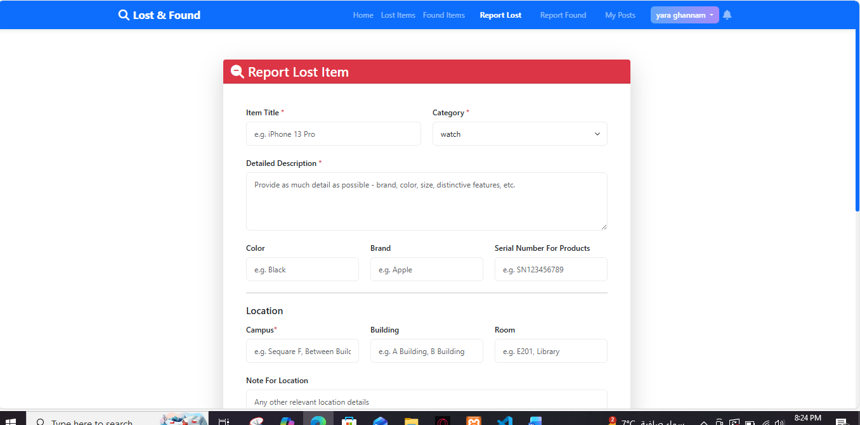

Figure 5.7: lost Suggestion UI For LFB

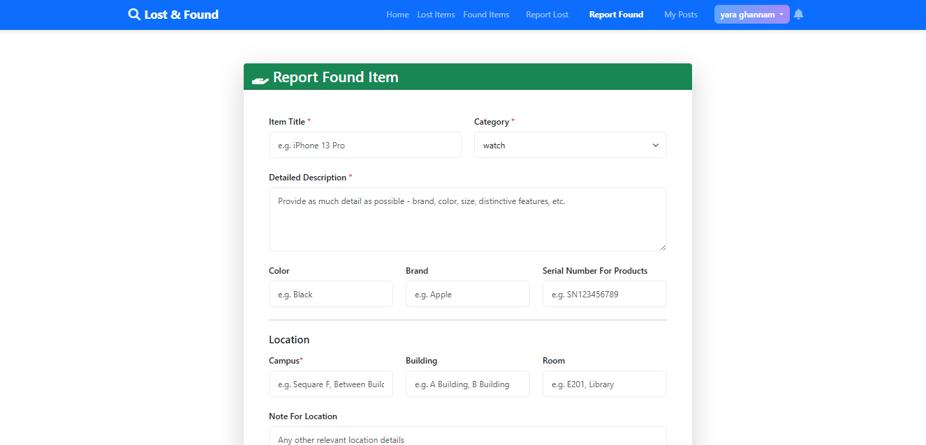
Figure 5.8: found Suggestion UI For LFB

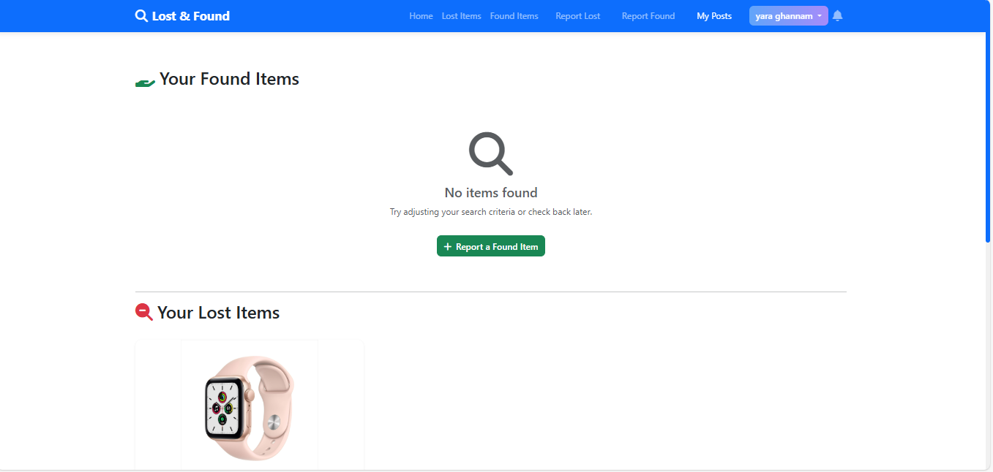

Figure 5.9: Profile management UI For LFB

  - Design patterns

- Singleton Pattern
Purpose: Ensures that only one instance of the Session Manager exists to control the user's login status.
Implementation in the project: When a user logs in, a single instance of the session is created and accessed by the rest of the system until they log out.
Benefit: Reduce memory consumption and ensure consistency of user data during the session.
Class Diagram:
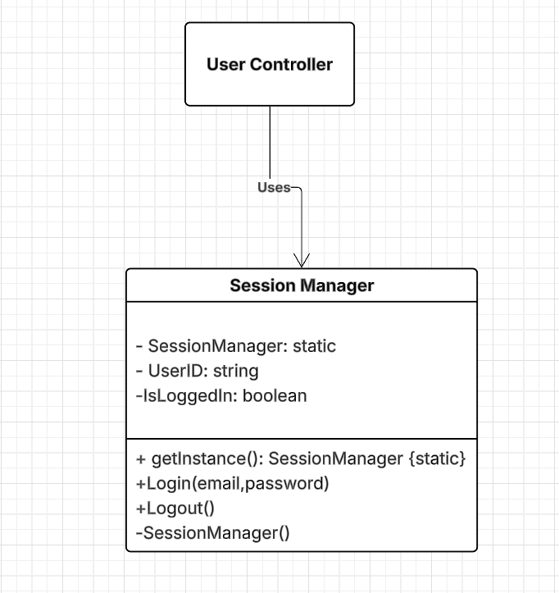

Figure 5.10: Class Diagram for Singleton Pattern

- Factory Method Pattern
Purpose: Create different workout plans based on user data (age, goal, activity level) without directly specifying the type in the code.
Implementation in the project: Upon entering user data, the Factory creates an appropriate WorkoutPlan object (e.g., a weight loss plan, a muscle building plan, or a general fitness plan).
Benefit: Facilitates adding new plan types in the future without modifying the underlying code.
Class Diagram:

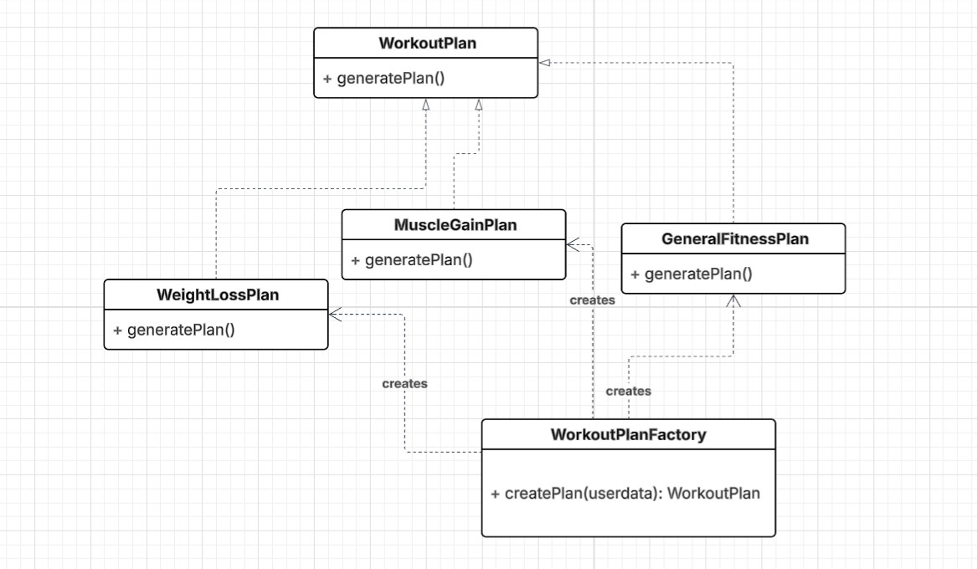

Figure 5.11: Class Diagram for Factory Pattern

- Strategy Pattern
Purpose: Change the way exercises are suggested to users based on the selected plan.
Implementation in the project: Each exercise plan has its own algorithm, which can be dynamically switched based on the user's preference.
Benefit: Flexibility in modifying exercise recommendation methods without affecting the rest of the system.
Class Diagram:
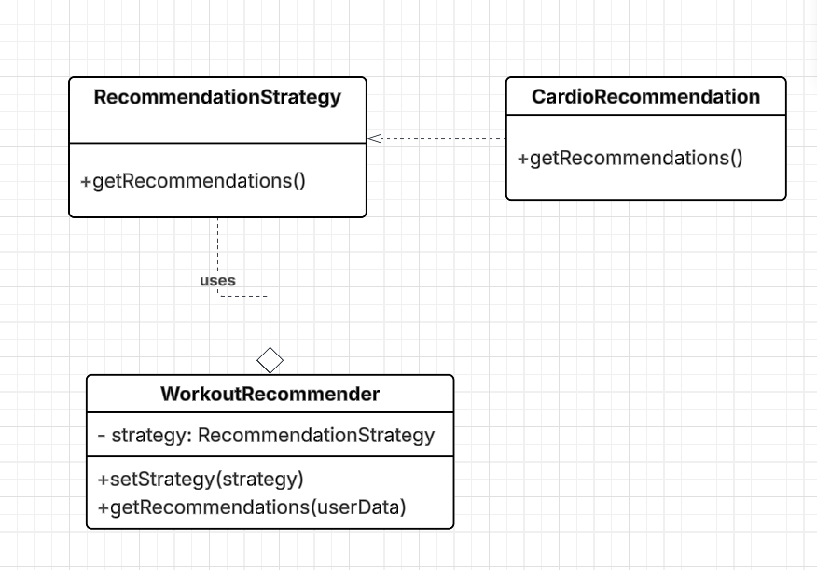

Figure 5.12: Class Diagram for Strategy Pattern

- Implementation & Quality Assurance
  - code documentation

  - Unit Test

Test Case ID | Requirement ID | Test Type | Test Case Name | Description | Steps | Precondition | Expected Result | Actual Result | Status
TC-1 | FR1 (User) | Unit | User Registration | Ensure users can register with valid email and password | - Go to registration page  - Enter valid data  - Click "Register" | User not registered, system operational | Account created. | Registration successful. | Pass
TC-2 | FR2 (User) | Unit | User Login | Confirm user can log in with valid credentials | - Go to login page  - Enter valid credentials  - Click "Login" | User is registered. | User successfully logged in. | User successfully logged in. | Pass

